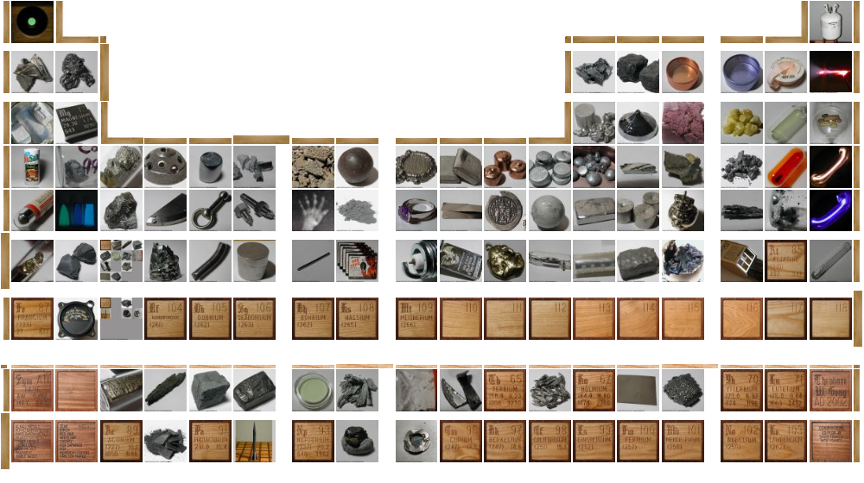

All IN THE FAMILY, Inc.*

For all your elemental needs

*An Equal Opportunity Employer
OUR MOTTO: The world is made of families – chemical families. We’re a family affair.

President and CEO
Mel Stephen and Tim McLeod
ALL IN THE FAMILY

Our company needs to hire people to sell our products. Just like companies such as Nike, which have a number of product ranges – athletic shirts, t-shirts etc., ALL IN THE FAMILY, Inc has a number of product ranges. Our product ranges correspond with the chemical families on the periodic table. For each product range a task force is responsible for understanding and selling their product range (in this case your family on the periodic table).

As you know, the periodic table was developed by Dmitri Mendeleev and Henry Mosley. The elements are placed in order of increasing atomic number (the number of protons in the nucleus) and are subdivided into vertical columns or groups known as families. These families have characteristics in common because of their similar electronic structure.

Your group has been hired to sell one of the families of the periodic table listed below. Your future with our company depends on your success with this project (see the salary (grade) rubric attached).

- Alkali Metals
- Alkaline Earth Metals
- Halogens
- Noble or Inert Gases
- Transition Metals
- Boron Family
- Carbon Family
- Nitrogen Family
- Oxygen Family
- Rare Earth Elements

As your employer I would like you and your sales team to accomplish the 5 tasks listed in your job description (see attached). To accomplish these tasks you will need to search the Internet for relevant websites. Below are several relevant websites for use. However, each group must provide a new website in the Product Information Page.

http://www.theodoregray.com/PeriodicTable/ Make sure you scroll down and click on an element

www.chemicalelements.com

www.webelements.com

http://www.chemsoc.org/viselements/pages/pertable_fla.htm

http://www.angelfire.com/ne/marissam/chem.html

http://pittsford.monroe.edu/pittsfordmiddle/rountree/periodic.htm

http://education.jlab.org/beamsactivity/6thgrade/tableofelements/index.html

Notes to Teachers

Overview

This lesson is designed for chemistry students to use the Internet to obtain information on a specific group or family (Family) of elements from the Periodic Table. In particular, each group will determine the similar chemical/physical properties for each Family including how all the electron configuration of the Family are related. Following the presentation of all the groups information, all students will have an understanding of all the Families of the Periodic Table.

Length of Lesson: 2-3 classes (68 minutes)

Essential Questions:

- How did you choose (i.e. what criteria(s) did you use to determine) the chemical/physical properties of your Family that you highlighted?
- How did the student determined the “hook” for the audience to understand the Family?

Target Standards: Mass Frameworks for Chemistry, Periodicity (Actual standards are
listed below)
Broad Concept: Periodicity of physical and chemical properties relates to atomic structure and led to the development of the periodic table. The periodic table displays the elements in order of increasing atomic mass.

3.1 Explain the relationship of an element’s position on the periodic table to its atomic number and mass.
3.2 Use the periodic table to identify metals, nonmetals, metalloids, families (groups), periods, valence electrons, and reactivity with other elements in the table.
3.3 Relate the position of an element on the periodic table to its electron configuration
3.4 Identify trends on the periodic table (ionization energy, electronegativity, electron affinity, and relative size of atoms and ions).

Resources/Materials: Computers, notebooks, textbook, presentation materials (posters, etc)
Outcomes:
- Students will understand how the electron configurations of elements in the same Family have similar characteristics.
- Students will be able to synthesis relevant information (from various sources including the Internet) into a presentation.

SALES TEAM JOB DESCRIPTION

A. Product Information Page

Produce a one page, word processed product information page including, if you can, the information below

- Where on the periodic table is the family located?
- What group is this family?
- What is the electronic structure that characterizes this family? How many valence electrons?
- Do elements from this family tend to form ions? What kind of ion?
- Give a few examples from this family.
- Give several important and interesting characteristics of elements in this family
- How do the elements from this family react with other elements?
- What are some uses for elements in this family?
- Where on our planet/in our universe might elements from this family be found?

- This sheet should provide a quick summary of important information about your element. Bullets or numbers under relevant headings work better than full sentences and paragraphs.
- You will be graded on how well organized you have outlined this material.
- Visuals, graphics, color, creativity will make this page more interesting to prospective buyers
- Remember no more than one page!
- At least one new website reference

B. Electronic Structure of your Family

Illustrate the electronic structure that characterizes your family by producing a model. This can be a 3D model, a computer generated animated visual, a poster – use your imagination. Remember to show the electrons on appropriate orbitals.

  - Sales Pitch

Give an 8 to 10 minute sales pitch to sell your family. Try to include the information listed in the product information page. You want to convince people to buy your family so your talk should be lively and memorable. Try to find a creative way to present your material (visuals from the internet, pictures, demonstrations, real examples, power point, etc.) Come prepared with all the necessary props and handouts. You may use the blackboard or overhead for your presentation. Please speak slowly and loudly so that everyone can hear you. The rest of the class will take notes from your presentation.

Knowledge on Other Families

As an employee of ALL IN THE FAMILY, Inc you need to be aware of all of our families. While the other sales teams are giving their sales pitches I will expect your team to take notes on these. Please color in the location of each of the families on the periodic table provided. You will need to print out a hard copy of this table. Label each family with its name, group number, valence electrons, common ions, electronic, examples and other relevant information (see criteria above)

Team Accountability Page

Please be sure to fill out Team Accountability page (see attached).

ALL IN THE FAMILY, Inc
Sales Team Accountability Page

Our Sales Team is Responsible for the following family on the periodic table:

__________________________

Please list the members of your team in the columns and list what each member did to contribute to this project in the space provided.

Name of Each Team Member | 1. | 2. | 3. | 4.
Family Information Page
Family Electronic Structure Model
Sales Pitch
Knowledge of ALL the Families
Percent Total Contribution
100%

Our signatures below confirm that the information in the above table is correct.:

1. ___________________________________ 2. ___________________________________

3. ___________________________________ 4. ___________________________________
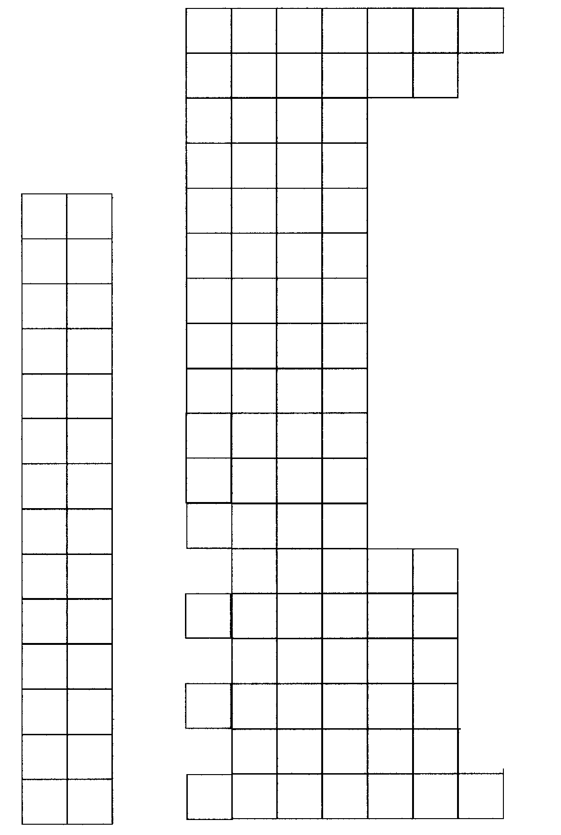

ALL IN THE FAMILY, Inc Salary Rubric

 | Not Acceptable | Needs Work | Developing | Accomplished | Exemplary | Score
Family Information  Page | 0-17 | 18-20 | 21-23 | 24-26 | 27-30
Family Information  Page | Missing most or all of the criteria that apply  Disorganized  More than one page | Needs more information  Needs to be better organized | Could include more information.  Could be better organized | Most of the criteria that apply were addressed  One page  Quite well organized | All of the listed criteria that apply were addressed.  One page  Well organized.  Extremely creative
Family Electronic Structure Model | 0-5 | 6-7 | 8 | 9 | 10
Family Electronic Structure Model | Does not accurately show electronic structure | Only partially shows electronic structure  Not very Creative | Only partially shows electronic structure  Creative | Accurately shows electronic structure  Quite creative. | Accurately shows electronic structure  Very creative
Sales Pitch | 0-17 | 18-20 | 21-23 | 24-26 | 27-30
Sales Pitch | Hard to follow  Seemed bored  Did not cover all criteria | Sometimes difficult to follow  Mediocre  Large gaps in covering criteria | Quite easy to understand  Sort of interesting  Covered Some of the material | Quite easy to understand  Quite interesting  Covered most of the criteria | Easy to understand  Extremely fun and interesting  Comprehensive overview criteria
Knowledge of All of the Families | 0-11 | 12-13 | 14-15 | 16-17 | 18-20
Knowledge of All of the Families | Little done to show knowledge of families | Some families shown on blank periodic table Some criteria shown | Most families shown on blank periodic table  Some Criteria shown | Almost all families shown on blank periodic table  Most Criteria shown | All families shown on blank periodic table  All criteria included in notes
Team Work | 0-5 | 6-7 | 8 | 9 | 10
Team Work | Not very much effort by anyone | Some team members contributed | Most team members contributed | Everyone gave a very good effort | Everyone on team gave their very best effort
TOTAL | You Are Fired  0-59  $0/yr | Office Assistant  60-69  $20,000/yr | Sales Person  70 – 79  $40,000/yr | Product Manager  80 – 89  $60,000/yr | Marketing Manager  90 – 100  $80,000/yr
Stephen, M.E updated 06/25/04

