The Rate and Order of
a Chemical Reaction
A basic kinetic study of a chemical reaction often involves conducting the reaction at varying concentrations of reactants. In this way, you can determine the order of the reaction in each species, and determine a rate law expression. Once you select a reaction to examine, you must decide how to follow the reaction by measuring some parameter that changes regularly as time passes, such as temperature, pH, pressure, conductance, or absorbance of light.
In this experiment you will conduct the reaction between solutions of potassium iodide and iron (III) chloride. The reaction equation is shown below, in ionic form.
2 I– (aq) + 2 Fe³⁺ (aq) → I₂ (aq) + 2 Fe²⁺ (aq)
As this reaction proceeds, it undergoes a color change that can be precisely measured by a Colorimeter (see Figure 1). By carefully varying the concentrations of the reactants, you will determine the effect each reactant has on the rate of the reaction, and consequently the order of the reaction. From this information, you will write a rate law expression for the reaction.
OBJECTIVES
In this experiment, you will
- Conduct the reaction of KI and FeCl₃ using various concentrations of reactants.
- Determine the order of the reaction in KI and FeCl₃.
- Determine the rate law expression for the reaction.
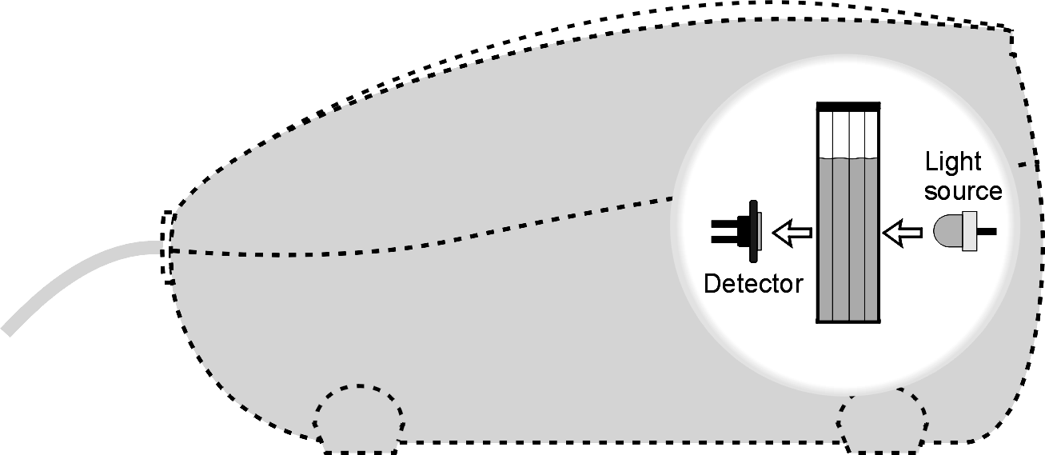
Figure 1
MATERIALS
Vernier computer interface | 0.020 M potassium iodide, KI, solution
computer | 0.020 M iron (III) chloride, FeCl₃, solution
Vernier Colorimeter | distilled water
plastic cuvettes | three 25 mL graduated cylinders
five plastic Beral pipets | three 100 mL beakers
PROCEDURE
1. Obtain and wear goggles.
2. Connect a Colorimeter to Channel 1 of the Vernier computer interface. Connect the interface to the computer with the proper cable.
3. Start the Logger Pro program on your computer. Open the file “25 Rate and Order” from the Advanced Chemistry with Vernier folder.
4. Set up and calibrate the Colorimeter.
- Prepare a blank by filling an empty cuvette ¾ full with distilled water. Place the blank in the cuvette slot of the Colorimeter and close the lid.
- If your Colorimeter has a CAL button, set the wavelength on the Colorimeter to 430 nm, press the CAL button, and proceed directly to Step 5. If your Colorimeter does not have a CAL button, continue with this step to calibrate your Colorimeter.
- Choose Calibrate  CH1: Colorimeter from the Experiment menu, then click .
- Turn the wavelength knob on the Colorimeter to the “0% T” position.
- Type “0” in the edit box.
- When the displayed voltage reading for Reading 1 stabilizes, click .
- Turn the knob of the Colorimeter to the Blue LED position (470 nm).
- Type “100” in the edit box.
- When the voltage reading for Reading 2 stabilizes, click , then click .
5. Obtain the materials you will need to conduct this experiment.
- Three 25 mL graduated cylinders.
- Approximately 100 mL of 0.020 M KI solution in a 100 mL beaker.
- Approximately 100 mL of 0.020 M FeCl₃ solution in a separate 100 mL beaker.
- Approximately 60 mL of distilled water in a third 100 mL beaker.
6. During this experiment you will conduct 5 trials. This step describes the process for conducting the trials using the Trial 1 volumes. When you repeat this process, use the correct volume for each trial based on the table below.
Trial | FeCl₃ (mL) | KI (mL) | H₂O (mL)
1 | 20.0 | 20.0 | 0.0
2 | 20.0 | 10.0 | 10.0
3 | 10.0 | 20.0 | 10.0
4 | 15.0 | 10.0 | 15.0
5 | 10.0 | 15.0 | 15.0

- Measure 20.0 mL of FeCl₃ solution into a 100 mL beaker.
- Measure 20.0 mL of KI solution into a second 100 mL beaker.
- Remove the cuvette from the Colorimeter and pour out the distilled water.
- Add the 20.0 mL of FeCl₃ solution to the beaker of KI solution. Swirl the beaker to mix.
- Rinse the cuvette twice with ~1-mL amounts and then fill it ¾ full. Wipe the outside of the cuvette with a tissue, place it in the Colorimeter, and close the lid.
7. Click  to begin collecting absorbance data. Data will be gathered for 2 minutes. Observe the progress of the reaction in the beaker.
8. When the data collection is complete, carefully remove the cuvette from the Colorimeter. Dispose of the contents of the beaker and cuvette as directed. Rinse and clean the beakers and the cuvette for the next trial.
9. Examine the graph of the first trial. Select a linear region of the graph that covers about 30-40 seconds of the reaction. Click the Linear Regression button, 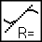. Record the slope, as the initial rate of the Trial 1 reaction, in your data table and then close the Linear Regression box.
10. Repeat Steps 6-9 to conduct Trials 2-5. Note: You will skip Step 6c in Trials 2-5.
DATA TABLE
Trial | [FeCl₃] | [KI] | Initial rate (sec^{–1})
1
2
3
4
5
DATA ANALYSIS
1. Calculate the molar concentration of FeCl₃ and KI for each reaction and record the values in the table above. Provide one example to show how you completed the calculation.
2. What is the order of the reaction in FeCl₃ and KI? Explain.
3. Write the rate law expression for the reaction.
4. Is it possible to calculate the rate constant, k, from your data? If so, calculate the rate constant. If not, explain why not.

